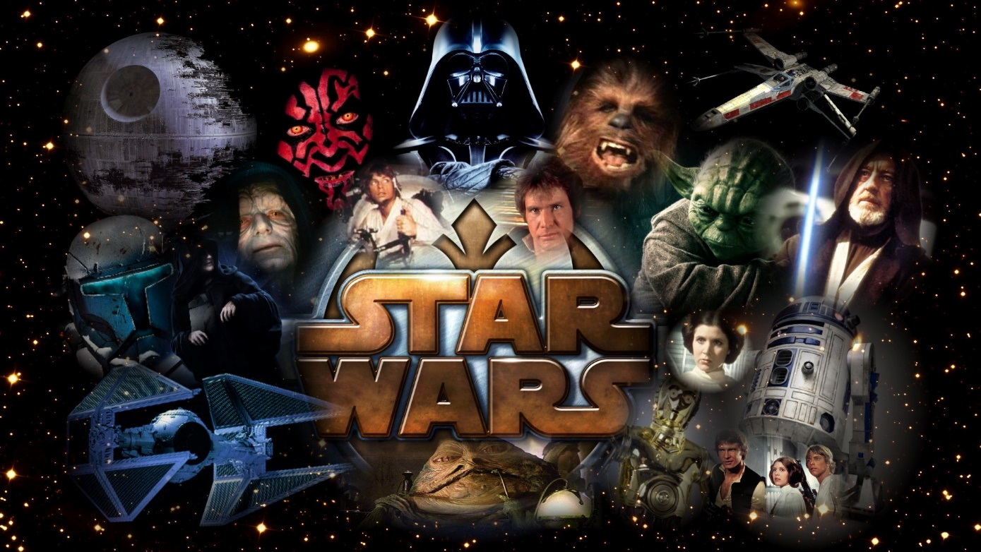

Star Wars

project

Galya Dodova | Opject oriented programming

Contents

Introduction 2

1.1. Descrition and Idea 2

1.2. Aim and tasks to be done 2

1.3. Structure of the documentation 2

Reviewing the subject 2

2.1. Simple definitions, concepts and algorithms 2

2.2. Finding the problems and the difficulty of the problem 2

2.3. Methods for solving the problems 2

2.4. Functional needs 2

Making the project 2

3.1. Architecture and diagrams 2

Testing and realization 2

4.1. Realization of classes 2

4.2. Memory control and optimization 2

4.3. Planning and creating testing scenarios 2

Conclusion 2

5.1. Review and future plans 2

Literature 2

# Introduction

## Descrition and Idea

The idea of the project is a system that finds jedi and prints the information for them.

## Aim and tasks to be done

The aim is an information system that represents jedi and planets.

Tasks are: making a jedi, making a planet, putting the jedi on the planet.

# Reviewing the subject

## 2.1. Simple definitions, concepts and algorithms

The main structure is polymorphism.

## 2.2. Finding the problems and the difficulty of the problem

## 2.3. Methods for solving the problems

## 2.4. Functional needs

# Making the project

## 3.1. Architecture and diagrams

# Testing and realization

## 4.1. Realization of classes

## 4.2. Memory control and optimization

## 4.3. Planning and creating testing scenarios

# Conclusion

Ready project representing information system for finding and educating jedi.

## 5.1. Review and future plans

# Literature

OOP lectures